PLACEMENT & INTERNSHIP REPORT 2025–26

The Placement Cell of Smt. K.G. Mittal College successfully facilitated internship and placement opportunities for students across various programs during the academic year 2025–26. Students were placed in diverse roles across sectors including Finance, Marketing, Human Resources, Customer Support, and Back Office operations .

Sr. no | Company | Number of Students Selected
1 | AIM | 3
2 | Zielhoch | 2
3 | Millennium Money Finance | 5
4 | The Leading Solutions | 4
5 | Acme Services | 1
6 | Vigours | 3
7 | Pracverse | 1
8 | Reliance Retail | 6
9 | TCS | 1
10 | Rekrut | 2
11 | Rekrut India | 3
12 | Quess Corp | 1
13 | Muthoot Finance | 3
14 | HDB Financial | 2
15 | Urban Money | 1
16 | Harjai Computers | 2
17 | Veninsva Financial Services | 2
18 | Right Hire 4 U | 1
19 | Housiey | 1
 | Total | 45

Training Conducted for Placements
Placement cell of Mittal college has conducted training programs in association with TNS
The program was designed to build comprehensive career and workplace readiness through six core modules along with additional supporting components. It begins with Personal & Professional Effectiveness integrated with Finance, which focuses on developing self-awareness, communication skills, workplace behavior, and a professional mindset, while also introducing essential financial concepts such as mutual funds, stocks, and insurance. Interview Readiness prepared participants for job opportunities by enhancing interview skills, practicing common questions, and building confidence .

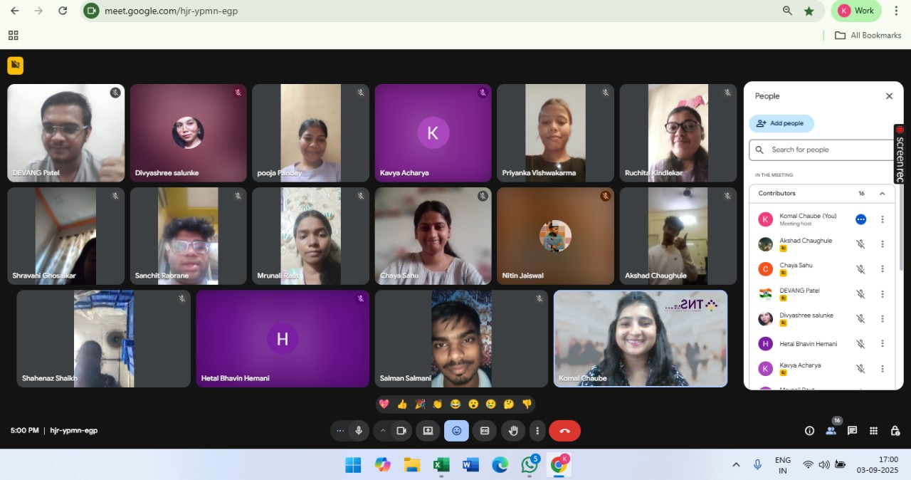

Career Readiness provided an overview of the BFSI sector (Banking, Financial Services, and Insurance), helping learners understand industry opportunities and career pathways. Moving forward, Work Readiness equipped individuals with knowledge of workplace professionalism, offer letters, KRA and KPI basics, as well as email etiquette and corporate communication.

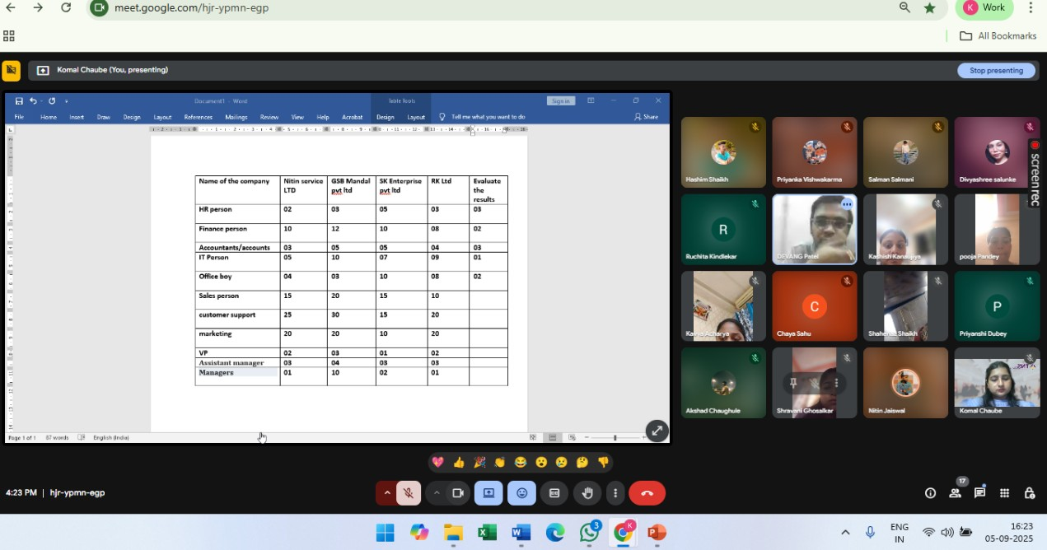

Digital Literacy focused on the use of essential digital tools and workplace technologies to improve productivity and efficiency.
Finally, Aptitude Training strengthened quantitative ability, logical reasoning, and analytical skills,ensuring participants are well-prepared for both recruitment processes and professional growth.

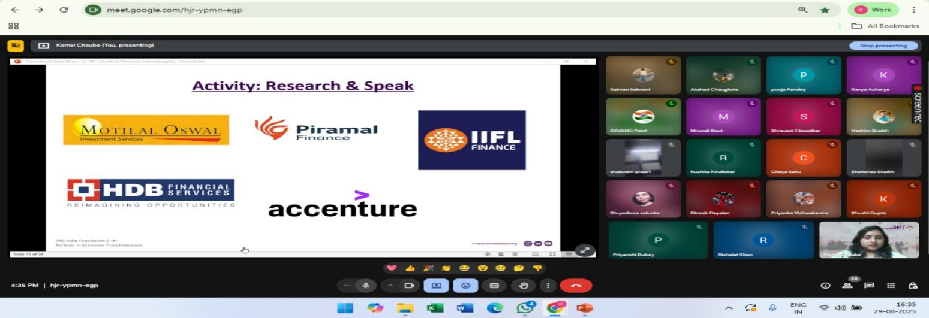

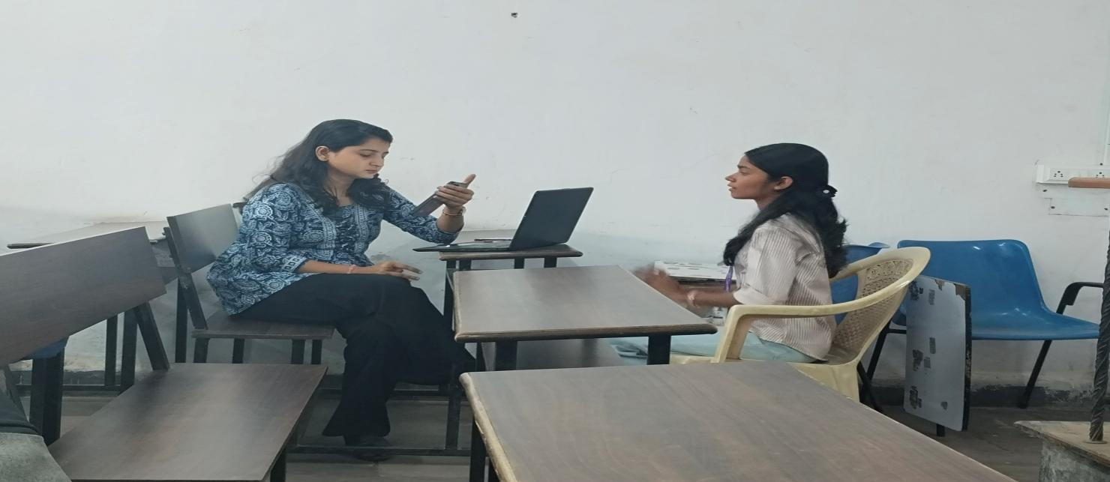

Mock Interviews Activities Conducted by Placement Cell
A mock interview session was conducted to help participants gain practical experience and improve their interview skills. The activity provided a real-time simulation of interview scenarios, allowing candidates to practice answering common questions, enhance their communication, and build confidence. Constructive feedback was shared on areas such as body language, clarity of responses, and overall presentation, enabling participants to identify their strengths and work on areas of improvement. The session proved to be highly beneficial in preparing candidates for actual job interviews.
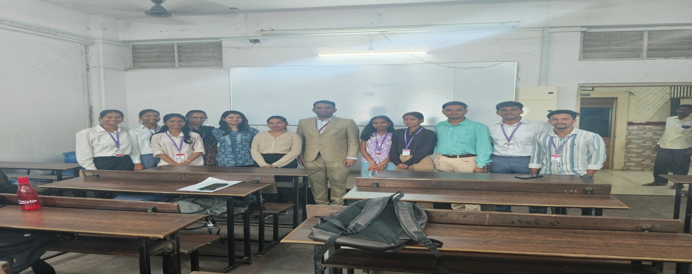

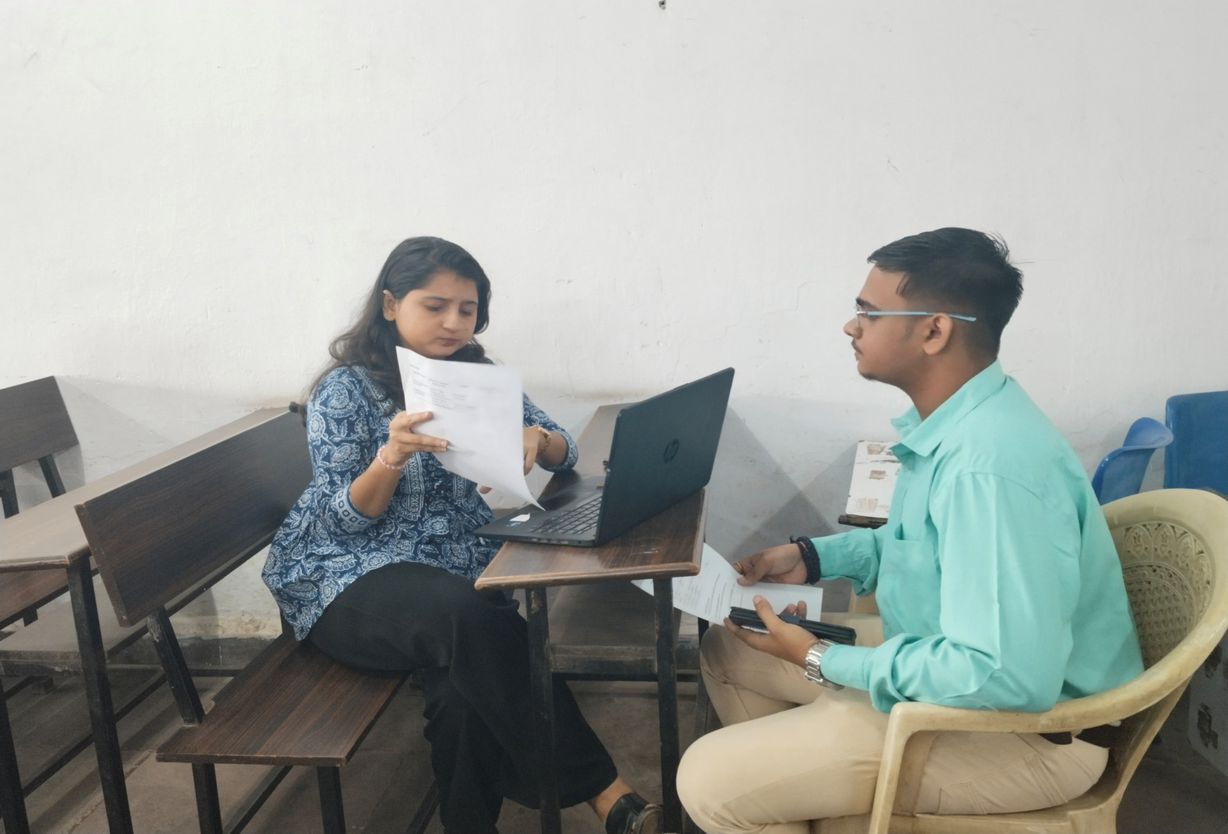

Resume Making Session Along with Self Introduction Preparation
A session on resume making along with self-introduction preparation was conducted to equip participants with essential job application skills. The session guided participants on how to create professional, well-structured resumes highlighting their strengths, skills, and achievements effectively. 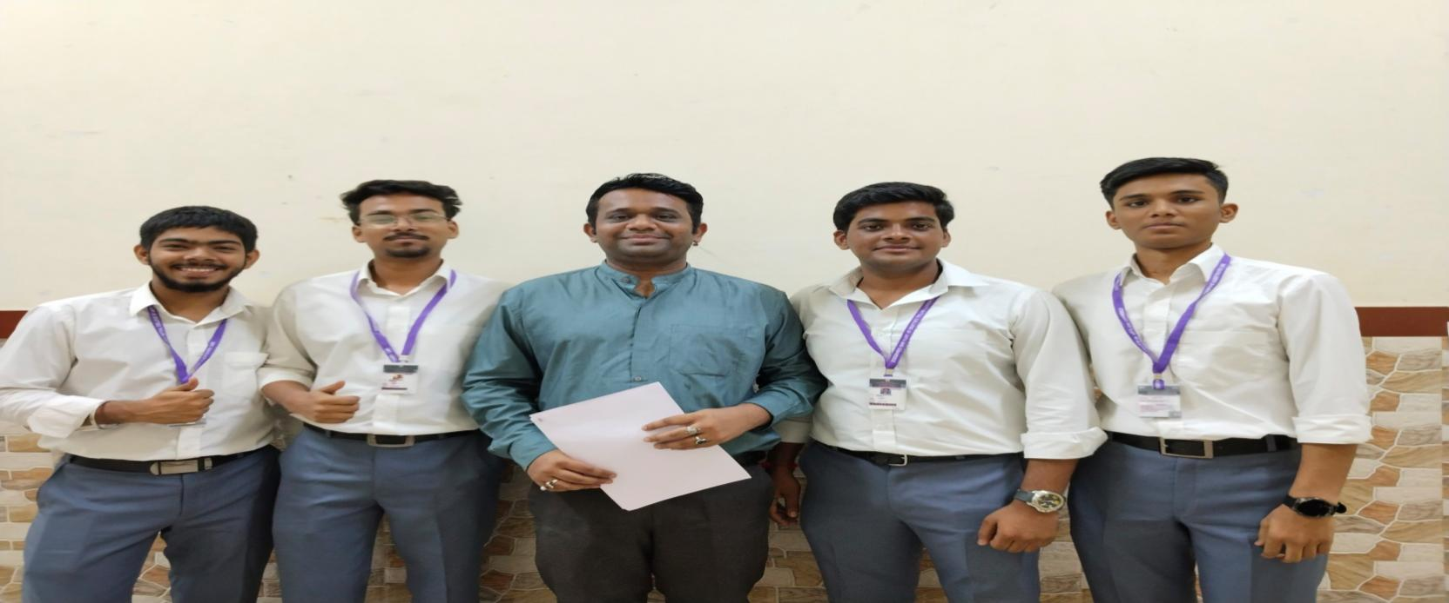
In addition, participants were trained to craft and deliver impactful self-introductions, focusing on clarity, confidence, and relevance. Practical tips and examples were provided to help them present themselves effectively in interviews and professional settings. Overall, the session enhanced participants’ ability to make a strong first impression on potential employers.

K.G. Mittal College has been actively conducting its Internship Program to bridge the gap between academic learning and industry requirements. The program focuses on providing students with practical exposure and hands-on experience through collaborations with various organizations across domains such as Software Development, Sales, and Mobile Application Development.
This report highlights the recent interactions with recruiters, the status of internship opportunities, and the actions taken to ensure successful student placements.

1. Objective of the Internship Program
The primary objectives of the Internship Program were:
- To provide industry exposure to students
- To enhance employability skills and practical knowledge
- To establish strong industry-academia collaboration
- To support students in securing internships aligned with their career goals

2. Internship Activities and Recruiter Interactions
The internship program involved continuous coordination with recruiters and organizations to identify opportunities and place students accordingly.
- Abhishek Pangerkar (Sales & Business Development Intern): Requirement mismatch identified; relevant BBA/BMS resumes to be shared. Update awaited.
- Vighnesh Sangekar (Kubic Technology): Delay acknowledged; feedback on resumes expected shortly.
- Micm India: No response received despite communication; follow-up required.
- Shefali (HR Consultant): Position for Mobile App Developer currently on hold due to financial year-end.
- Aniruddh (Java Developer): Twelve students appeared for the interview; ten were selected. Out of these, three students are currently undergoing training.
- Raj (TY Student): No openings available for freshers after direct communication with HR.
- Farhan (Aspire Technology): Follow-up pending due to recruiter unavailability.

3. Description of the Activity
The Internship Program was conducted as an ongoing placement and coordination activity aimed at connecting students with relevant industry opportunities. The process involved identifying suitable job roles, sharing student resumes, maintaining communication with recruiters, and conducting regular follow-ups.

Efforts were made to align student profiles with industry requirements. Continuous tracking of recruiter responses and student progress ensured systematic management of internship opportunities.
The program also involved addressing challenges such as delays in recruiter responses, role mismatches, and limited opportunities in certain domains. Despite these challenges, proactive follow-ups and coordination helped in achieving positive outcomes in several cases.

4. Participation
Students from various streams actively participated in the internship program. Particularly, students from technical backgrounds such as B.Sc. IT and B.Sc. CS were involved in opportunities related to software and development roles, while management students were considered for sales and business development roles.

5. Learning Outcomes
Through this internship program, students were able to:
- Gain practical industry exposure and work experience
- Understand real-world job requirements and expectations
- Improve communication, technical, and professional skills
- Enhance problem-solving abilities in workplace scenarios

